Internal Logistics Optimization

INTERNAL LOGISTICS OPTIMIZTION

A PROJECT REPORT

*Submitted by*

K TUSHAR NAHAR

*in partial fulfillment for the award of the degree*

*of*

BACHELOR OF TECHNOLOGY

IN

PRODUCTION ENGINEERING

from

National Institute Of Technology, Tiruchirapalli

July 2013

# Acknowledgement

This project would not have been possible without the kind support and help of many individuals and organizations. We would like to extend our sincere thanks to all of them.

I am highly indebted to **Mr. Venkatapthy, Mr. Sundarrajan** of Lean Promotion Officeand **Mr. Hanif Rahman** of Value Stream C&B for their guidance and constant supervision as well as for providing necessary information regarding the project & also for their support in completing the project.

I would like to express my gratitude towards Mr. Arpujuraj and members of Wabco India Limited for their kind co-operation and encouragement which helped us in completion of this project.

# About

## Spring Brake Actuators

The function of Spring Brake Actuator is to produce braking forces at the foundation brakes. It serves the function of service, secondary and Parking/Hand Brakes

This assembly shown above is a combination of diaphragm brake chamber and spring actuator with mechanical rear wind off arrangement. The diaphragm arrangement is for actuating service brakes. The spring-loaded piston is for actuating secondary/parking brake. The mechanical wind off arrangement helps to release the spring brake in case of air pressure loss due to some brake failure. This provision temporarily facilitates movement of vehicle to the nearest garage for rectifying the fault.



Figure 1: Spring Brake Actuator

## Brake Chamber

Air brake chambers are round metal containers, located at each wheel, where compressed air is converted into mechanical force to apply the brakes and stop the vehicle. There are two kinds of air brake chambers — service and spring brake chambers. A service brake chamber contains a flexible rubber disc called a diaphragm, a metal rod called a pushrod and a return spring. When you press the brake pedal, compressed air fills the service brake chamber, causing the diaphragm to move and push out the pushrod to apply the brakes. When air pressure is released, the pushrod is returned to its original position by the spring inside the chamber. The pushrod and a lever — called a slack adjuster — link the brake chamber to the brake assembly (which contains the brake drum or disc). When you press the brake pedal, the pushrod extends farther from the brake chamber, moving the slack adjuster forward. The motion of the slack adjuster transfers to the brake assembly, causing the brake shoes or pads to make contact with the brake drum or disc. This action of the pushrod extending from the brake chamber is called pushrod stroke, and stroke length is the distance that the pushrod travels out of the chamber. Due to the design of brake chambers, each has a limited pushrod stroke-length capacity, beyond which no brake force is produced. The brake linkage includes a device to adjust the position of the brake chamber in relation to the position of the brake shoes. As brakes wear, the linkage must be re-adjusted to ensure the pushrod stroke is always within its normal operating range. This type of brake re-adjustment is required at regular intervals.

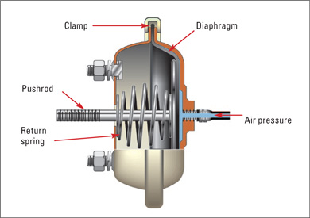

Figure 2: Brake Chamber

# Project Abstract

The present reports describes the work done to implement a system of internal logistics that is based on the principles of lean manufacturing in the assembly shop floor to reduce certain problems that were observed in the system. A brief description of the current system is given to obtain a brief glimpse on the problem that are faced by the work force especially the worker who supplies material to the assembly line who will be referred to as “Spider Man or Water Spider”.

The scenario which is being described below is of Spring Brake Actuator (Type 24-24).The initial filling of material for the first batch of products that are going to be manufactured for the current shift is done by the water spider who has worked in the previous shift. Following this the materials that have to be used in that shift is replenished by the water spider who is working in the current shift. Materials that are used in the assembly lines are classified into three classes based on their size(A,B,C). Based on the type of storage that is used in the assembly line these materials are covered in a particular amount of time. The materials that are covered fastest are the A class materials .Some of the A-Class materials that are used are Non Pressure Plate, Clamp ring, Diaphragm, Ram, Cylinder, Flange. In the line side storage these materials are segregated into two groups Non Pressure Plate, Clamp ring, Diaphragm & Ram, Cylinder, Flange. These two groups are supplied separately in two different movement of the workers .NPP is brought in 32 nos. , Clamp ring in 36 nos. , Diaphragm in 30 nos. while in the next movement the water spider for storage he replenishes Flange which is moved to the supermarket and the supermarket mixes the three different material into a single trolley having ram in 32 nos, flange in 16 nos. and cylinder in 30 nos. There is no indication given to the worker on how much material has to be brought into the line .Gaiter which is a common material that is used in all lines is supplied to the storage inside the shop floor in 10 packets each having 30 Nos. Small parts such which are classified as C class items are stored for the complete shift. Fork is supplied every two three hours. Certain materials such as springs are replenished based on demand.

There are certain problems associated with the system associated with the above system. Some of the problems are:

* There is no signal to inform the workers that replenishment of certain material is required.
* There is no standard storage in lines based on the size of the items
* There is no standard time at which these materials are consumed
* Since there is no signal for the worker to understand that a given item is missing and there is no standard time at which these material will get depleted the whole system depends on the predictive ability of the worker which is not always reliable
* There is non-standard movement of water spider into the assembly line
* There is non-standard movement of the worker in areas other than that which is required for their work in the given station
* The above movement of the worker out of his station reduces the efficiency of his station
* There is excess space consumption due to storage inside the assembly floor
* There is unnecessary non-value adding movement of the worker that is required for obtaining information on depletion of items.

There were some other problems that were observed which could be improved:

* The usage of space inside the line was not optimized
* The 5S system that was used currently in the line could be improved if this space inside the line could be used more efficiently
* There were certain items present in the line which were not necessarily used in the assembly of products which could be eliminated.

Due to the inefficiency of the system that was used previously the amount of work load on the water spider was paramount. The physical work well as the mental workload could be reduced by implementing a “Pull System” and hence the project began keeping in mind the main objective –“Reducing the Work Load of the Water Spider”.

# Introduction

This project solely focuses on lean manufacturing in order to improve the effectiveness of manufacturing of a particular product. To understand the importance of the project it is important to have an understanding of lean principles which are explained below

Lean manufacturing is a production practice that focuses on elimination of expenditure of resources on any other activity than which adds value to the product in the perspective of the consumer where value is any process or property that the consumer is willing to pay for. Essentially lean manufacturing is based on the idea of reducing the amount of work done on the product while preserving the value of the product.

There are two approaches that can be taken to understand lean manufacturing. The first is considering lean as a set of tools which assist in identification and steady elimination of wastes. As waste is eliminated quality is improved while production time and cost are reduced. Examples of the fore mentioned tools are kanban, 5S, Value Stream Mapping.

The second approach which is promoted by Toyota is where focus is kept on improving the flow or thereby eliminating any non-uniformity that occurs during this flow .Common techniques that were used to improve this flow includes production leveling, pull production and heijunka box.

Following Toyota’s there are three main types of waste muda,muri and mura.

## Muda

Muda is a Japanese term that refers to work that is associated with non-value adding operation. One of the key steps in Lean is identification of the processes that add value .By classifying the operations into these two categories it is then possible to start action to improve the former and eliminate the latter. Once value-adding work has been separated from waste then waste can be subdivided into 'needs to be done but non-value adding' waste and pure waste. The clear identification of 'non-value adding work', as distinct from work, is critical to identifying the assumptions and beliefs behind the current work process and to challenging them in due course. There are seven different areas where the waste associated with muda usually occurs

### Transportation

Each time a product is moved it stands the risk of being damaged, lost, delayed, etc. as well as being a cost for no added value. Transportation does not make any transformation to the product that the consumer is willing to pay for.

### Inventory

Inventory, be it in the form of raw materials, work-in-progress (WIP), or finished goods, represents a capital outlay that has not yet produced an income either by the producer or for the consumer. Any of these three items not being actively processed to add value is waste.

### Motion

In contrast to transportation, which refers to damage to products and transaction costs associated with moving them, motion refers to the damage that the production process inflicts on the entity that creates the product

### Waiting

Whenever goods are not in transport or being processed, they are waiting. In traditional processes, a large part of an individual product's life is spent waiting to be worked on.

### Over-Processing

Over-processing occurs any time more work is done on a piece than is required by the customer. This also includes using components that are more precise, complex, higher quality or expensive than absolutely required.

### Over-Production

Overproduction occurs when more products are produced than is required at that time by your customers. Overproduction leads to excess inventory, which then requires the expenditure of resources on storage space and preservation, activities that do not benefit the customer.

### Defects

Whenever defects occur, extra costs are incurred reworking the part, rescheduling production, etc. This results in labour costs, more time in the "Work-in-progress". Defects in practice can sometimes double the cost of one single product. This should not be passed on to the consumer and should be taken as a loss.

## Mura

Mura is the Japanese term that refers to the waste associated with unevenness or irregularity in the flow of work. This unevenness or non-uniformity in the flow of material is usually associated with Just In Time production which are based on keeping little or no inventory, rather supplying the production process with the right part, at the right time, in the right amount, and first-in, first out component flow. Just in Time systems create a pull system in which each sub-process withdraws its needs from the preceding sub-processes, and ultimately from an outside supplier. When a preceding process does not receive a request or withdrawal it does not make more parts.

[Production levelling](http://en.wikipedia.org/wiki/Production_leveling), also called heijunka, and frequent deliveries to customer are key to identifying and eliminating Mura. The use of different types of [Kanban](http://en.wikipedia.org/wiki/Kanban" \o "Kanban)  systems to control inventory at different stages in the process are key to ensuring that pull is happening between sub-processes. Levelling production, even when different products are produced in the same system, will aid in scheduling work in a standard way that encourages lower costs.

## Muri

Muri is a Japanese term which is associated with the waste due to overburden on workers

Muri can be avoided through standardized work. To achieve this a standard condition or output must be defined to assure effective judgment of quality. Then every process and function must be reduced to its simplest elements for examination and later recombination. The process must then be standardized to achieve the standard condition. This is done by taking simple work elements and combining them, one-by-one into standardized work sequences. In manufacturing, this includes:

* Work Flow, or logical directions to be taken,
* Repeatable Process Steps and Machine Processes, or Rational methods to get there, and
* [Takt time](http://en.wikipedia.org/wiki/Takt_time), or reasonable lengths of time and endurance allowed for a process.
* When everyone knows the standard condition, and the standardized work sequences, the results observed include
* Heightened employee morale (due to close examination of ergonomics and safety),
* higher quality,
* improved productivity, and
* reduced costs.

## Lean Principles

Lean manufacturing is based on five principles whose usage can lead to uninterrupted flow of material. These are as given below.

### Value

Every company needs to understand what value the customer places upon their products and services. It is this value that determines how much money the customer is willing to pay for the product and services. This leads to a top-down target costing approach that has been used by Toyota and others for many years. Target costing focuses on what the customer is willing to pay for certain products, features, and services. From this the required cost of these products and services can be determined. It is the company’s job to eliminate waste and cost from the business processes so that the customers price can be achieved at great profit to the company.

### Value Stream

The value stream is the entire flow of a product’s life-cycle from the origin of the raw materials used to make the product through to the customer’s cost of using and ultimately disposing of the product. Only by a study and clear understanding of the value stream and its value-add and waste a company truly can understand the waste associated with the manufacture and delivery of a product or service. Lean thinking advocates supplier and customer partnership and radical supply chain management to eliminate waste from the entire value stream.

## Flow

One very significant key to the elimination of waste is flow. If the value chain stops moving forward for any reason, then waste will be occurring. The trick is to create a value-stream where the product (or its raw materials, components, sub-assemblies) never stop in the production process Where each aspect of production and delivery is fully synchronized with the other elements. Carefully designed flow across the entire value chain will tend to minimize waste and increase value

### Pull

The way to ensure that nothing is made ahead of time and builds up work-in-process inventory that stops the synchronized flow is to use a pull approach. A traditional western manufacturer will use an MRPII or ERP style of production planning and control whereby production is "pushed" through the factory based upon a forecast and a schedule. A pull approach states that we do not make anything until the customer orders it. To achieve this requires great flexibility and very short cycle times of design, production, and delivery of the products and services. It also requires a mechanism for informing each step in the value chain what is required of them.

## Perfection

A lean manufacturer sets his/her targets for perfection. The idea of total quality management is to systematically and continuously remove the root causes of poor quality from the production processes so that the plant and its products are moving towards perfection. This relentless pursuit of the perfection is the fifth principle of lean.

# Lean Goals

The espoused goals of Lean manufacturing systems differ between various authors. While some maintain an internal focus, e.g. to increase profit for the organization, others claim that improvements should be done for the sake of the customer. Since lean practices that have to be implemented in a manufacturing have heavy dependence on the goal which were kept in mind while planning of lean practices, the selection of these goals become important. Some of the goals that are commonly kept in mind while planning of lean practices are.

**Improve quality:** To stay competitive in today's marketplace, a company must understand its customers' wants and needs and design processes to meet their expectations and requirements.

**Eliminate waste:** Waste is any activity that consumes time, resources, or space, but does not add any value to the product or service.

**Reduce time:** Reducing the time it takes to finish an activity from start to finish is one of the most effective ways to eliminate waste and lower costs.

**Reduce total costs:** To minimize cost, a company must produce only to customer demand. Overproduction increases a company’s inventory costs because of storage needs.

# Lean Tools

The system proposed in this project uses various methodologies which are associated with lean manufacturing .A brief understanding of these tools is given below to gain a better oversight of these projects.

## Kanban

Kanban is scheduling system for just in time production in lean manufacturing. This system is used to control the logistical chain of a given production system. The kanban system was inspired from the working of a supermarket and hence a brief explanation of how a supermarket works can give us an idea of the objectives the kanban system wants to achieve.

In a supermarket, customers obtain the required quantity at the required time, no more and no less. Furthermore, the supermarket stocks only what it expects to sell within a given time frame, and customers take only what they need, since future supply is assured. This led to view a process as being a customer of one or more preceding processes, and the preceding processes are viewed as a kind of store. The "customer" process goes to the store to obtain required components which in turn causes the store to restock.

Kanban aligns inventory levels with actual consumption; a signal is sent to produce and deliver a new shipment when material is consumed. These signals are tracked through the replenishment cycle, bringing visibility to both the supplier and the buyer.

Kanban uses the rate of demand to control the rate of production.

One important determinant of the success of production scheduling based on demand "pushing" is the ability of the demand-forecast to receive such a "push". Kanban, by contrast, is part of an approach where the "pull" comes from the demand. The supply or production is determined according to the actual demand of the customers. In contexts where supply time is lengthy and demand is difficult to forecast, often, the best one can do is to respond quickly to observed demand. This situation is exactly what a kanban system accomplishes, in that it is used as a demand signal which immediately travels through the supply chain. This ensures that intermediate stocks held in the supply chain are better managed, and are usually smaller.

For effective use of kanban, five rules have to be strictly used. They are

* Later process picks up the number of item indicated by the earlier process.
* Earlier process produces components in the number indicated by the kanban
* No items are produced or supplied without a kanban
* Defective products are not sent to the next process. This is to produce 100% defect free products
* The number of kanban decides the sensitivity of the system. Where the supply response is not quick enough to meet actual demand fluctuations, more kanban are kept to have an adequate buffer to any loss that may be caused by delay or deficit in the supply response

As indicated earlier every pull system requires a signal that indicates the demand of the product required from the next process with respect to a previous process. One such means to broadcast this signal is Kanban cards.

## Kanban Cards

Kanban cardsare a key component of kanban and signal the need to move materials within a manufacturing or production facility or move materials from an outside supplier in to the production facility. The kanban card is, in effect, a message that signals that there is a depletion of product, parts, or inventory that, when received, the kanban will trigger the replenishment of that product, part, or inventory. Consumption therefore drives demand for more production, and demand for more products is signalled by the kanban card. Kanban cards therefore help to create a demand-driven system. Demand-driven systems lead to faster turnarounds in production and lower inventory level.

The overview of the kanban system is completed with a brief description of three bin system .

## Three-Bin System

There are three bins present in the system. One bin is on the factory floor (the initial demand point), one bin is in the factory store (the inventory control point), and one bin is at the supplier. When the bin on the factory floor is empty (because the parts in it were used up in a manufacturing process), the empty bin and its kanban card are returned to the factory store (the inventory control point). The factory store replaces the empty bin on the factory floor with the full bin from the factory store, which also contains a kanban card. The factory store sends the empty bin with its kanban card to the supplier. The supplier's full product bin, with its kanban card, is delivered to the factory store; the supplier keeps the empty bin. This is the final step in the process. Thus, the process will never run out of product, and could be described as a closed loop in that it provides the exact amount required, with only one spare bin so there will never be an oversupply. This 'spare' bin allows for the uncertainties in supply, use, and transport that are found in the inventory system.

## 5S Methodology

5S is the name of a workplace organization method. It is named after the five Japanese words - *seiri, seiton, seiso, seiketsu and* *shitsuke.* The list describes how to organize a work space for efficiency and effectiveness by identifying and storing the items used, maintaining the area and items, and sustaining the new order. When translated in English these words mean sort ,straighten , shine , standardize.

## *Seiri* or Sort

Sorting means to sort through everything in each work area. Keep only what is necessary. Materials, tools, equipment and supplies that are not frequently used should be moved to a separate, common storage area. Items that are not used should be discarded or recycled. Sorting can be classified into five steps:

* Cleaning: The purpose of "sorting" is to identify unnecessary items and eliminate them from the workplace. To do this first requires cleaning up the workplace so you can see what you have. Clean up accumulations of dirt, debris, oil, grease, broken tools, excess materials, and scrap
* Classifying: As you are cleaning up you'll find tools, equipment, materials and supplies. As each item is found, classify it as to the type of object. Scrap metal might go directly to a recycling bin. An item classified as tool might go to a collection area for further identification.
* Ownership: This step involves deciding the ownership of a certain tool or object that is used. Once ownership is determined, the owner can decide what to do with the item-store it, pass it onto another work area or department or dispose the item.
* Red Tagging: If an item cannot be identified, or if it cannot be classified, or if ownership cannot be determined, then it should be red tagged. Red tagging involves marking items with a red tag so that each item can be evaluated and dealt with appropriately. Red tagged items are collected in an area that allows potential owners to examine them and determine what should be done with the items for which they are responsible.

The above 5 steps under sorting improves the efficiency, increases quality and makes it simpler to spot problems and enhance productivity.

## *Seiton* or Set

This is the second step in a 5S program: organizing, arranging, and identifying everything in a work area, as well as throughout the facility, so that items can be efficiently and effectively retrieved and returned to their proper storage location.

The basic focus of this part of 5S is to create efficient and effective storage systems such that anyone can find the tools, materials, and supplies they need, and anyone can return those tools, materials, and supplies to their proper storage locations. A second key principle of set in order is that the most commonly used tools should be readily available. Those items that are not frequently used should be kept out of the way by storing them in a more remote location.

* Labeling: To accomplish these goals storage areas, cabinets, and shelves should be clearly marked with signs and labels. Place labels on the outside of doors to identify the storage space. Label the interior shelves so that individual items can be consistently and easily returned to their proper storage locations.
* Applying Set: The key principle in "5S Set in Order" is: a place for everything and everything in its place, with everything properly identified and labeled. Items that are used frequently should be stored close to where they are used. Items that are used infrequently should be stored in a common area further from the location where they are used. If several items are used together, then store them together.  For example, drill bits should be stored in the same location as drills. Store things in place people would logically look to find them. Identify all items (including tools, jigs, molds, bits, etc.) and label them so that anyone can identify and return them to their proper storage location.
* Mapping: A 5S map is tool that can help show what needs to be done in the 5S Set In Order step. A 5S map is a diagram, or floor plan, that provides an overview of a work area, a process, a department, office, or work station. It provides a picture that shows where machines, storage areas, work in progress, supplies and workers are located. It should also include a short description of the tasks that are done in the area.

Use a 5S map to identify:

* where equipment and machines are located (where the work is done)
* where storage areas are needed
* how those storage areas should be arranged
* how people move around in, or move through a work area

The second step of the 5S set in order helps in customizing the work area to improve efficiency. It helps in implementing visual organization to streamline workflow

## *Seiso* or Shine

Once every individual work area is sorted out and organized it needs to be maintained in that condition. This requires regular cleaning. Inspection is often accompanied with this cleaning.

Having a clean work area has many advantages. One of the more significant is that it makes it easy to spot fluid leaks and equipment that needs maintenance. When a work area is clean machine operators can notice malfunctions such as fluid leaks, vibration and misalignment, and breakages. These problems, if not addressed, can result in equipment failure, safety hazards, and loss of production.

## *Seiketsu* or Standardize

The 5S practices developed in the first three steps of the 5S methodology should be standardized and made easy to accomplish. A work structure and written standards need to be developed that will support the new practices .

These standards develop habits that results in 5S being effectively and efficiently implemented.

Making people aware of the new standards, and helping them to remember the new standards correctly, are commonly done using labels, signs, posters and banners. This brings us to another tool that is usually used in lean systems visual communication

## Visual Communication

Visual management is the process of displaying critical information “so that anyone entering a work place, even those who are unfamiliar with the detail of the processes, can very rapidly see what is going on, understand it and see what is under control and what isn’t. Essentially, the current status of the operation can be assessed, at a glance.

On the factory floor, visual management can take shape in the form of key performance indicators that relate to production quantity, speed and quality, as well as machine uptime and downtime. In keeping with visual management’s requirement that the information can be seen at a glance, the information is shown on large displays that can be seen from a distance and by more personnel than just the machine operator.

## *Shitsuke* or Sustain

Sustain refers to on-going training and maintenance that is carried out to maintain the 5s system. Training is crucial for 5S success. People need to be reminded about the requirements of the established 5S standards. When there are changes that will effect your 5S program -- such as new equipment, new products, new work rules -- make the needed changes in the standards to accommodate those changes, and provide training on the new standards.

An effective way to have on-going training, and to maintain adherence to standards, is to use custom 5S posters and signs. By using custom posters and signs the message can be tailored to the specific department or situation. This improves both communication and retention of the message.

It is important to change posters and signs on a regular basis. A message that remains in place for an extended period of time eventually is ignored and becomes invisible. By changing your posters and signs, and keeping the messages fresh, they will continue to draw attention, be seen, and be remembered.

Since the project is based on improving the internal logistics, a brief overview of logistics is given

## Logistics

Logistics is the part of the supply chain processes that plans, implements, and controls the efficient, effective forward and reverse flow as well as storage of goods and services, and also related information between the point of origin and the point of consumption in order to meet customers’ requirements. It describes the entire process of materials and products moving into, through, and out of firm.

Logistics can also be defined as the Process of moving and handling goods and materials, from the beginning to the end of the production, sale process and waste disposal, to satisfy customers and add business competitiveness. It is a Process of anticipating customer needs and wants, acquiring the capital, materials, people, technologies, and information necessary to meet those needs and wants; optimizing the goods- or service-producing network to fulfil customer requests; and utilizing the network to fulfil customer requests in a timely way.

## Lean Logistics

A brief overview need to be given on Lean Logistics. This system can be described by “4C’s”

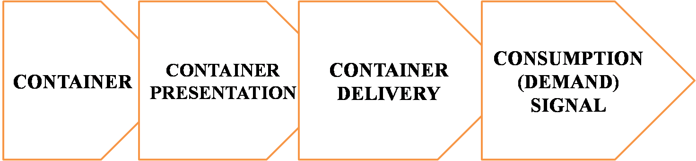

Figure 3: 4C’s of Lean Logistics

* Container: Container is the first C in lean logistics and is defined as the ideal container that has to be stored in the line .There are certain criterion which must be met while choosing a container. The container will be filled with the required amount which depend on the amount of demand that is required per hour .This required amount must fill about 80% the container. This number may vary based on the shape of the container. The material of the container must be harder than the material it will hold so as to prevent excessive wear and tear. The container chosen are of standard dimensions so as to reduce the cost that may be added to obtain container of custom shapes and size. The five types of containers that were chosen were A-11080, B- BIN15, C-

BIN AG-25, D-BIN 32150, E-BIN AG-45. 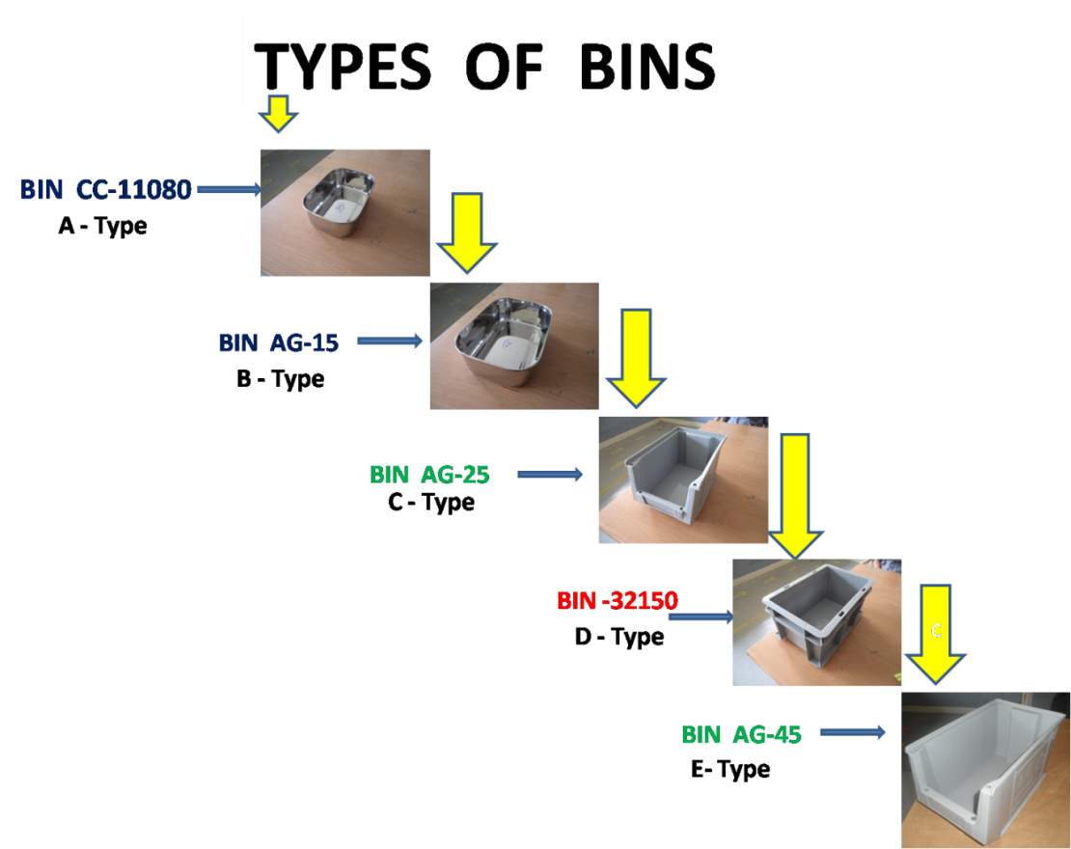

Figure 4: Type of Bins

* Container Presentation: Container presentation represents the storage of these ideal containers in the lines .Sloping channels or slides are used to act as conveyors for containers. Points under consideration for conveying containers were
  + There should be no significant deformation under tension, torsional or bending loads in these chutes
  + Space constraints of the station must kept in mind while designing these containers
  + Certain consideration must be made based on the 5S principle of *Seiton* such as
    - Items that are used frequently should be stored close to where they are used. Items that are used infrequently should be stored in a common area further from the location where they are used.
    - If several items are used together, then store them together
    - The chutes designed must be such that ideal container for that chute must fit only in that chute .This is done so as to make it easier for the workers to locate the chute for a given container
    - The chutes must be placed such that comfort of the workers is maximized so as to improve the efficiency of the workers
  + Worker Safety
  + Ergonomic factors
  + Quality

The goals of Container and Container Presentation are to reduce Inventory, Volume Fluctuation, Floor Area, and Distance Handling and to increase Value Added Activities, Flexibility and Ergonomics.

* Container Delivery: Container Delivery represents the system of logistics that exists between the stores and the assembly line. The implementation of the kanban system takes effect in this logistic process. The container delivery takes place as mentioned previously in the three bin system of kanban which is now abstracted to a two bin system. There are two bins present in the system. One bin is on the factory floor, one bin is in the factory store (the inventory control point). When the bin on the factory floor is empty, the empty bin and its kanban card are returned to the factory store (the inventory control point). The factory store replaces the empty bin on the factory floor with the full bin from the factory store, which also contains a kanban card. Factors that are taken into consideration are
  + Takt time
  + Short Cycles
  + Variable Quantity
  + Ergonomics
  + Quality

Goals of container delivery are to reduce Inventory, Distance/part, and handling stages and to increase Utilization (logistics), Flexibility and Ergonomics.

* Container Signal: Container signal involves visual management. Goal of container signal is to reduce empty trips, missing parts on supply inventory and to increase efficiency and flexibility.

# Methodology

## DMAIC

The method used to find the solution for improving the logistic is the five step DMAIC cycle. DMAIC refers to a data-driven improvement cycle used for improving, optimizing and stabilizing business processes and designs.

As mentioned above DMAIC consists of five steps. These steps are defined as follows

## Define

The purpose of this step is to clearly articulate the business problem, goal, potential resources, project scope and high-level project timeline.

## Measure

The purpose of this step is to objectively establish current baselines as the basis for improvement. This is a data collection step, the purpose of which is to establish process performance baselines. The performance metric baseline from the Measure phase will be compared to the performance metric at the conclusion of the project to determine objectively whether significant improvement has been made.

## Analyse

The purpose of this step is to identify, validate and select root cause for elimination. A large number of potential root causes of the project problem are identified via root cause analysis The top 3-4 potential root causes are selected using multi-voting or other consensus tool for further validation. A data collection plan is created and data are collected to establish the relative contribution of each root causes to the project metric, Y. This process is repeated until "valid" root causes can be identified.

## Improve

The purpose of this step is to identify, test and implement a solution to the problem; in part or in whole. Identify creative solutions to eliminate the key root causes in order to fix and prevent process problems.

## Control

The purpose of this step is to sustain the gains. Monitor the improvements to ensure continued and sustainable success. Create a control plan. Update documents, business process and training records as required.

The steps described above are the steps that are used to solve any regular problem using DMAIC methodology. Elaborating on the above steps we divide these steps into ten steps which are divided into three modules. They are:

* Define And Measure Current State
* Analyze And Propose Improvements
* Control

In the first step i.e. Define and Measure Current State the objective of define is to identify the project opportunity and to verify and validate that it represents legitimate breakthrough potential. The purpose of the measure is to evaluate and understand the current state of the process. This includes collecting data on quality, cost, throughput/cycle time and other factors like the time spent to perform various work activities. Deciding what and how much data to collect are important tasks; there must be sufficient data to allow for a thorough analysis and understanding of the current process performance with respect to the key metrics.

The Data that are collected are used as the basis for determining the current state or baseline performance of the process. The data collected during the measure step can be displayed in the form of histograms, stem and leaf diagram and Pareto charts.  
Steps Followed in this module are:

* Define the goal (management expectation)
* Define the scope with job site overview(baseline: standard observation sheet)
* Understand the repetitiveness of the existing process (call system)
* Breakdown processes into processes steps and determine timing, frequency, skills, tools etc (standard work combination table)
* Evaluate utilization with balance chart for all the scope vs. available working time.

In Analyse and Propose Improvementsmodules the objective of analyse is to use the data from the measure step to determine the cause and effect relationships in the process and to understand different sources of variability. In other words, in the analyse step we want to determine the potential causes of the defects, quality problems, customer issues, cycle time and throughput problems or waste and inefficiency that motivated the project. The objectives of improve are to develop a solution to the problem and pilot test the solution. Pilot test is the form of confirmation experiment; it evaluates and documents the solution and confirms the solution attains the project goals. This may be an iterative process, with the original solution being refined, revised and improved several times as a result of the pilot test’s outcome.

Steps Followed in this module are:

* Perform workload analysis (VA/NVA)
* Future state proposal (eliminate NVA reduce combining simplify then rebalance)
* In Control the objectives are to complete all remaining work on the project and to handoff the improved process to the project owner along with the process control plan and other necessary procedures to ensure that the gains from this project will be institutionalized. Improvements will be implemented in the other similar processes in the business. Steps Followed in Control are:
* New standard work defined and implemented. New call system.
* Validate if standard is followed
* Adjust as customer demand fluctuates

# Implementation

## Classification of items

Following the principles of 5S associated with Sorting cleaning was done of the workplace in the sense that items that were not associated with assembly were eliminated and removed from the assembly station. The next step of the sorting process which was classification began with classification of items into three classes. This classification was made based on the rate of consumption of these items in the standard storage containers that were going to be used.

* Class A: Items that were large in size were usually classified as A class item. These items were either too large to be stored in standard containers or their rate of consumption was too great or their storage in standard containers becomes inefficient.
* Class B: These items were items which were moderate in size. These items were stored to last for about half the period of a shift. Though classification was based on size in most cases ,some of these items were classified as B class items due to ergonomic reasons that usually aroused due to their weight
* Class C: These items were items which were small in size. Storage of these items was such that these items would last for an entire shift.

## Creation of a Part Matrix

Following this classification of the materials the next step that was followed for implementation was the creation of a part matrix. This part matrix contains a list of material that are used in a line along with certain details of these parts such as Current bin size, Qty/bin, Qty/product, Supplier pack details, Consumption / hour, Supplier pack Qty, Ideal Bin size & quantity .

**Ideal Bin Assignment** After this part matrix has been completed; the next step that was followed for the implementation of a new system was assigning an ideal standard bin size that was to be used to store Class B and Class C items. Class A items were stored in customized storage utilities. There were five types of bins that were used to for storage of items mentioned above- Bin 11080, Bin 15,Bin 25,Bin 32150 and Bin E(Bin 45).The table given below specifies the various dimensions of these standard bins.

Table 1: Bin Dimensions

|  |  |  |  |
| --- | --- | --- | --- |
| BIN NOMEN-CLATURE | LENGTH(mm) | WIDTH(mm) | HEIGHT(mm) |
| A-11080 | 165 | 110 | 60 |
| B BIN15 | 185 | 135 | 60 |
| C BIN25 | 230 | 150 | 120 |
| D-32150 | 300 | 200 | 150 |
| E BIN45 | 340 | 210 | 200 |

The ideal bin assignment depends on the demand per hour. This is obtained through data present as per the previous production.

Next we consider the class in which the given component belongs as per the previous classification(B or C)we calculate the required amount of the given component .

Table 2: Demand per Line of Brake Chamber

|  |  |  |  |  |
| --- | --- | --- | --- | --- |
| DEMAND | LINE 1 | LINE 2 | LINE 3 | LINE 4 |
| HOURLY | 21 | 42 | 56 | 56 |
| FOR FOUR HOURS | 84 | 168 | 224 | 224 |
| FOR EIGHT HOURS | 168 | 336 | 448 | 448 |

Table 3: Demand per Line of Spring Brake Actuator

|  |  |  |  |  |  |
| --- | --- | --- | --- | --- | --- |
| DEMAND | LINE 1 | LINE 2 | LINE 3 | LINE 4 | LINRE 5 |
| HOURLY | 60 | 60 | 48 | 51 | 24 |
| FOR FOUR HOURS | 240 | 240 | 192 | 204 | 96 |
| FOR EIGHT HOURS | 480 | 480 | 384 | 408 | 192 |

If the material is a C class item then the material is made to last for an entire shift, that is, 8 hours and if the material is a B class item then the material is made to last for 4 hours. Now the next consideration is the quantity of the given component that is used in a single product. This number is multiplied with the demand per hour and the time period for which it must be made to last. For example let us take a fork that is used in SBA Type 2024. Based on its size it is classified as a B class and hence it should be made to last for 4 hours. The next consideration is the demand per hour which is 60 for SBA type 2024. The quantity of fork that is used in a single product is 1.So the ideally required amount of fork is 240.

The next step is reality check. Reality check is the process where the number of components that fit in a given container is checked manually. This is the final step that is taken before finalizing the given container

In the above case of a fork based on the reality check the in chosen is Bin E which is bin 45

## Ideal Workload Calculations

Ideal workload Calculations are done so as to obtain a glimpse on the effectiveness of the current system with respect to the previous system based on certain parameters that give an indication on the work load on the operator

Work Load Calculations are done based on the following formulas

* Coverage(Hours)=(Quantity /Bin)/(Demand/Hour)
* Delivery cycle in hours=(Time period for which a shift lasts)/ (Time period for which the material lasts in the container ideally)
* Bins per Cycle=(Demand per hour*Quantity required per assembly*delivery cycle per hours)/(Quantity per Bin)

From the above formulae we have calculated workload on the operator according to the number of bins getting empty for every one hour.

## Two Bin System

The Kanban system is a system where the parts required by an area are restocked on a continuous requirement basis from its store area. It normally works on a two bin system where each required part is stocked in the area in two bins which contain an equal predetermined quantity of parts. The bins are placed one behind the other. All the parts are used from the first or top bin first, which after it gets empty, is immediately sent back to be restocked.

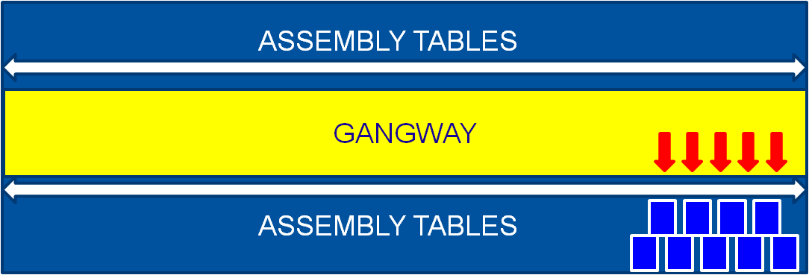

A complete description of the given two bin system is given below:

* The salient property about this system is that there are two sides which are used for material movement, guide ways which are pathways for material movement and assembly floor where the operators and assembly floor where the operators and the workstations are located. In this system the material is fed from the pathway while the material is stored in the assembly floor. This movement from the guide ways to assembly floor occurs automatically due to sloping channel
* First two bins are stored from the guide way by the Spiderman. They slide along the channel stop in the side of the assembly floor. This due to inclination present in the chute.
* After one of these bins is used, the empty bin is kept in sloping channel that is sloped toward a lower level in the guide way .This sloping channel is indicated using a red. These empty bins are kept with a kanban card which provides the water spider with essential information such as the component number, component name etc.
* The empty bin is collected by the water spider and replaces it with filled bin in the input channel, which is indicated by a green color. This input channel slopes to a lower level towards the assembly floor.

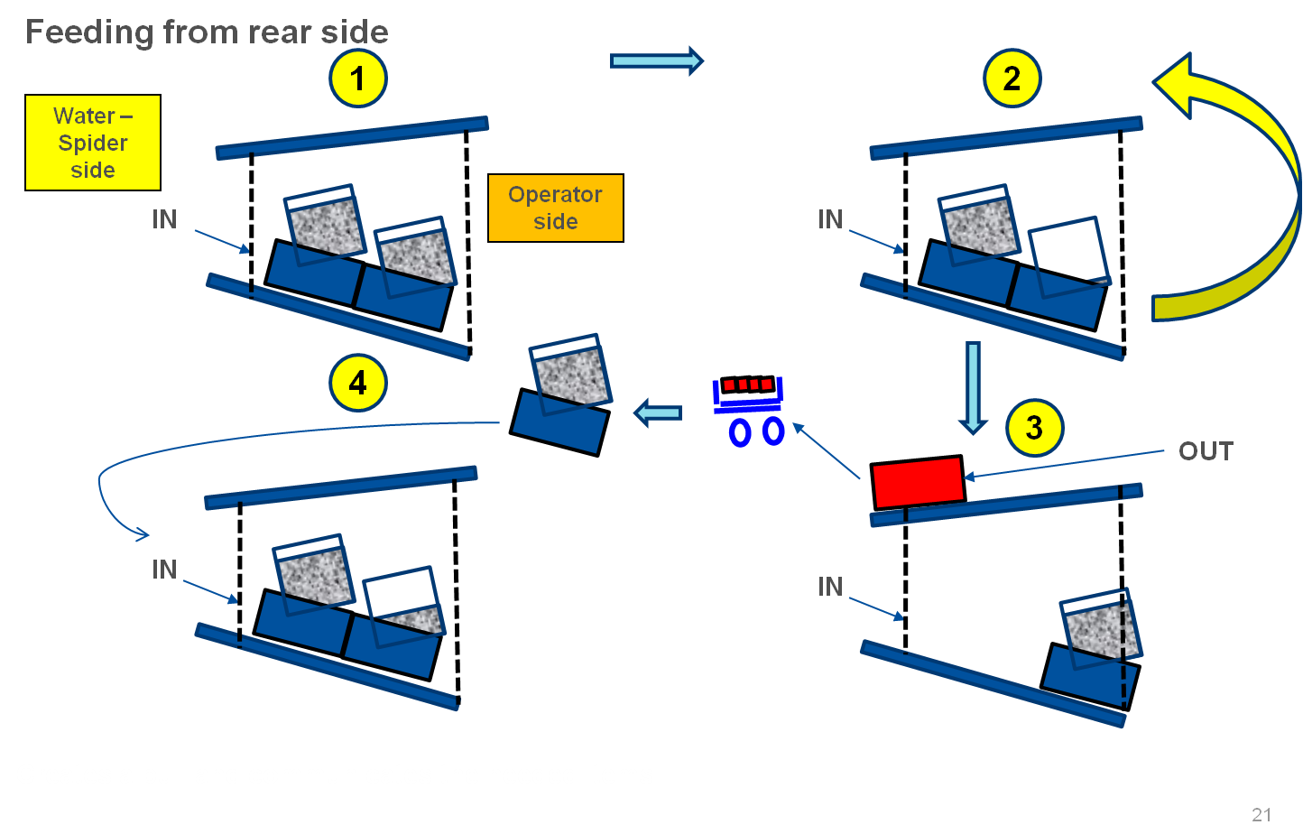

## Chute Design

There are certain factors which are considered while designing the chutes that hold the containers .They are:

* Work Stations: The table where a particular assembly process is taking place is known as a Work Station. Each and every work station has its own assembly process. The materials used in every station are different and based on the materials used chutes are designed and are either attached to the work table or fixed closer to the worktable without affecting the assembly process.
* Bin Sizes: The chutes are designed based on the bin sizes that are used in the given station. Both the input and output bin sizes are used based on these containers

Table 4:Part name ,Bine Size, Dimension of a station

|  |  |  |  |  |
| --- | --- | --- | --- | --- |
| S/NO | Part no | Part name | Bin size | Dimensions(mm) |
| 1 | 100472690 | Retainer | A-11080 | 330*110 |
| 2 | 100472670 | White Filter | B BIN15 | 370*145 |
| 3 | 100910620 | Nut | B BIN15 | 370*145 |
| 4 | 100472680 | Yellow Filter | C BIN25 | 435*160 |
| 5 | 100460130 | Fork | D-32150 | 590*230 |
| 6 | 100472700 | Gaiter | E BIN25 | 680*240 |

Similarly collecting the data of all the four lines, number of stations and the parts used in every station, the ideal bin sizes of those parts accordingly these chutes are designed for all the stations in all the nine lines. Hence two bin system with 100% FIFO is implemented in all the nine lines.

## Visual Management

As Visual management is the process of displaying critical information so that anyone entering a work place, even those who are unfamiliar with the detail of the processes, can very rapidly see what is going on, understand it and see what is under control and what isn’t. Essentially, the current status of the operation can be assessed, at a glance.

To aid in production control, clear and easy communication of information about jobs, it decided to use Green and Red Reflective Stickers.

The input chute from where the material is fed inside by the water spider is wrapped by Green Reflective Sticker which implies that bins with material have to be fed inside the chute from that particular side. Similarly, the output side of the chute is wrapped with Red Reflective Stickers which imply that empty bins have to be placed by the operators on to this output chute. This is illustrated by the following Figure

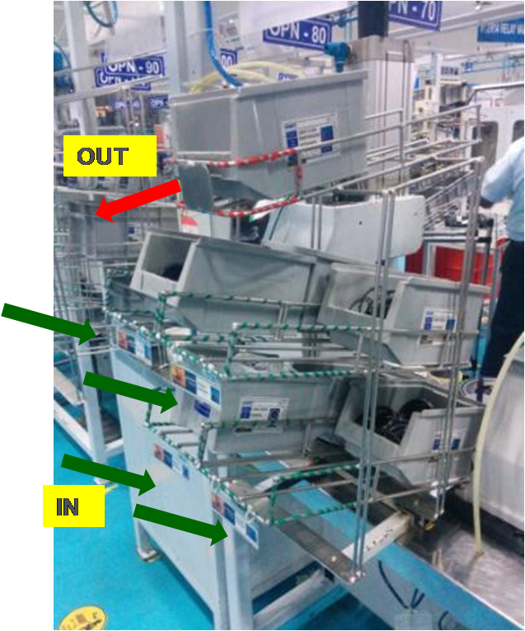

Figure 5: Visual Management

Another visual control is done by sticking material feeding points on to the ground so that it gets easier for the water spider to identify the material feeding points.The material feeding point stickers is shown in the Figure. 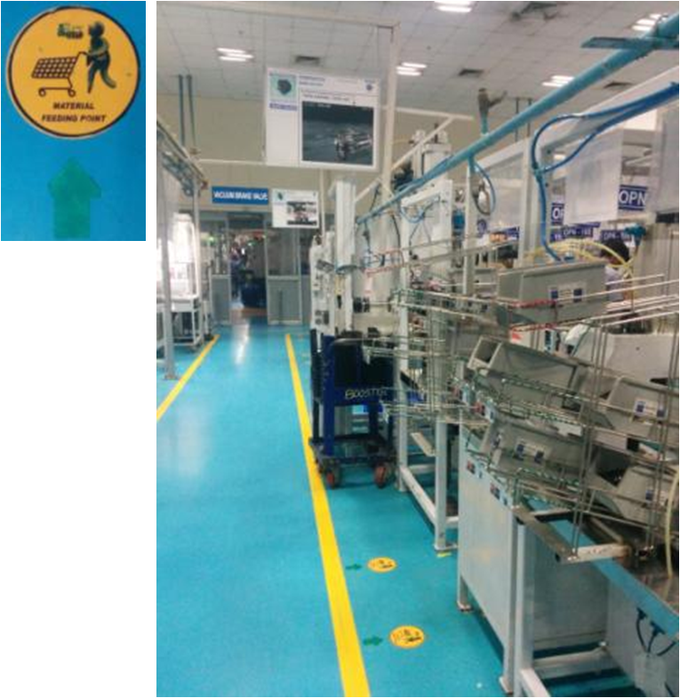

Figure 6: Indication of Material Feeding Points

## Signalling Mechanism

After a detailed analysis of the signalling mechanisms two concepts that can be implemented were proposed. On further analysis the best concept among the two would be selected for implementation.

In the first proposal as shown in the Figure, firstly a Kanban post has to be established at every line. Every bin will contain a Kanban card. Whenever consumption of particular bin starts, the operator has to place this Kanban card inside the Kanban post. The water spider will come and collect the cards from the Kanban post. These cards will be taken to the stores where he will get the material to fill the bins according to the information on the card.

Though this is a flexible technique (as per the demand), with a good possibility of inventory optimization, the time at which cards are to be collected is not defined, missing of cards would more prone to happen and there is a Possibility of Line stoppage due to undefined time interval. This entire setup occupies extra space in every line and at times there is a possibility of inventory stock piling up.

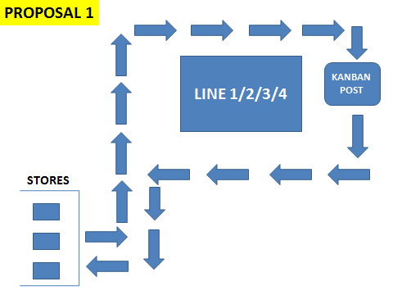

Figure 7: Kanban proposal I

In the second proposal as shown in Figure the bin acts as a Kanban. Hence the Kanban cards are attached to the bin therefore the bin is called a Kanban bin. The water spider has to collect the empty bins from the output chute in his first cycle. Then he will go back to the stores, fill the bins and come into the line feeding the bins into the input chute in the second cycle.

This proposal being a flexible technique along with high levels of inventory optimization the other advantages are:

It does not require extra space.

Line stoppage is possible only when a bin is missing which is less likely to happen when compared to missing of cards.

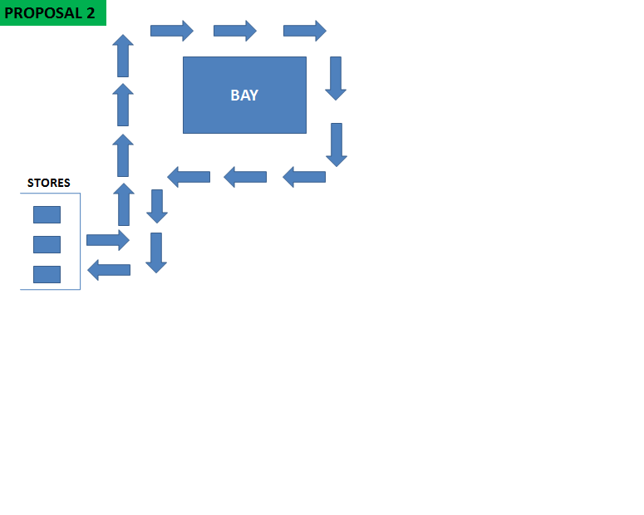

**Figure: Kanban proposal II**

Kanban cards are made as stickers and are stuck to the bins.

Out of the proposals keeping in mind the number of variants that were present in each of the nine lines, Proposal one was observed to be more practical and was recommended for implementation

A trolley is designed in order to collect all the empty bins from the line, take them to the stores, Fill all the empty bins, place them in the trolley again and get them into the assembly line .this trolley is called B and C class items trolley as shown in Figure .This has been designed for B and C class items only.

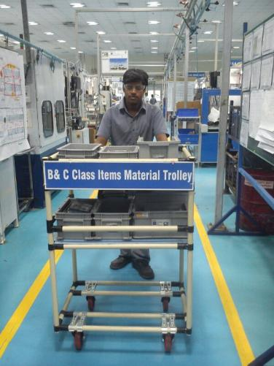

**Figure 7: B and C class items trolley**

## Supplier Pack Size Optimization

Re-handling/ repacking contributes to most of the NVA . Hence a concept of repacking has been introduced.

Previously the parts obtained from the supplier were stored in the Raw material Stores. This system followed a push mechanism where these parts were stored in the line side storage area. Whenever the bin gets empty operators had to open the packet of parts, fill it into the bin. The remaining packet was then stored in the bin. This caused lots of inventory stock pile ups.

In order to avoid re-handling of parts in the assembly line that includes taking out the covers inside the assembly line, non-standard pack sizes which causes excess inventory stock pile up in the line etc. a repacking area outside the assembly line was proposed. The pack sizes of these parts are changed in such a way that the pack size is equal to ideal bin quantity. In the repacking area water spider gets all the empty bins. He just has to open the cover and refill the bins with the respective parts. As the pack size is equal to the ideal bin quantity it is concluded that we will not have inventory stock piling up and also the entry of covers into the assembly line now is restricted. Hence it becomes simple, at the same time the work load on the water spider gets evenly divided.

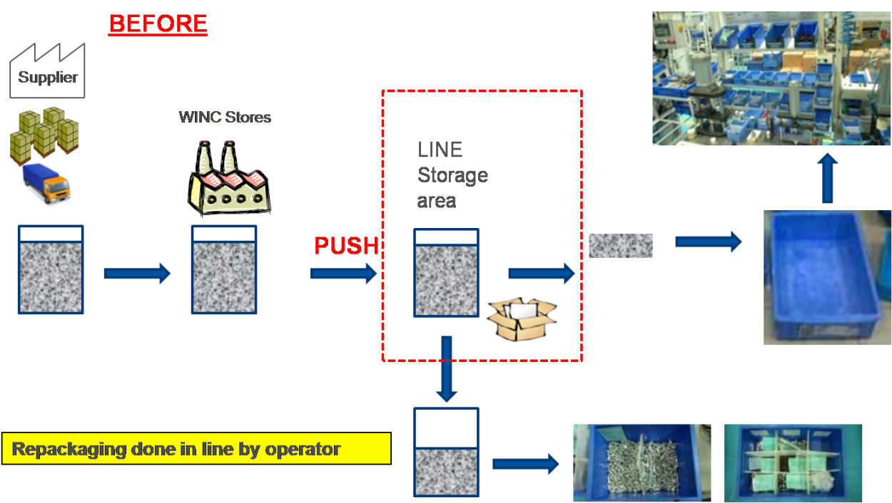

**Figure 8: Supplier Pack Size Optimization**

For getting the pack size equal to ideal bin quantity changes has been proposed based on the part consumption information in every line along with the bin size and its respective quantity. These changes have been negotiated with the suppliers in order to get the new pack sizes.

In the Figure every part is assigned a particular bin on the basis of few calculations. After this ideal bin size designation two bin system is implemented in the bay. When one bin gets empty this bin is taken to the repacking area where the bin is filled with the required part. After the implementation of changed supplier pack size where supplier has sent the quantity according to the requirement, pack size must be equal to ideal bin quantity. SAP has been updated with the changed batch quantity. SAP in future will be integrated with barcode scanning system in such a way that whenever we obtain the stock, it will be invaded in the stores only when these parts are according to the new supplier’s pack size data. If not then the stock will not be allowed to invade. Based on the trigger SAP will generate some barcode stickers with the part number and quantity based on the requirement. Hence possibility of storing huge stock is also reduced as this entire process is based on the trigger.

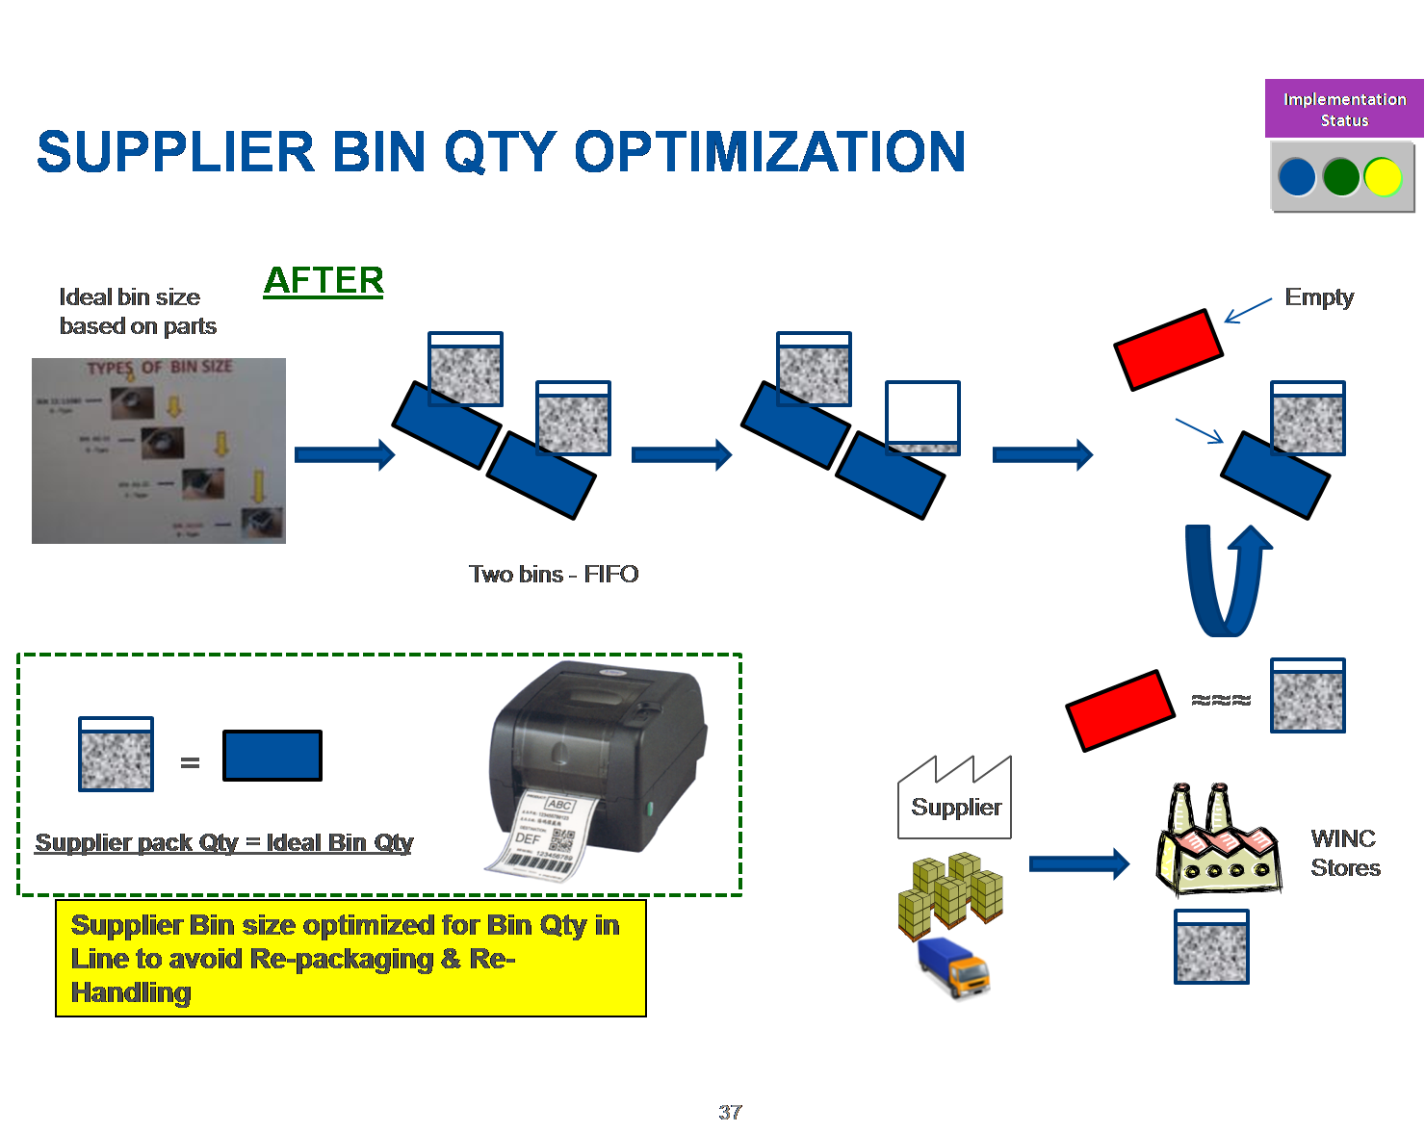

Figure 9: Supplier Pack Size Optimization (Future State)

By the implementation of Two Bin System, Ideal Containers, Bin Chutes and FIFO there have been a lot of Material improvements.

Moreover BIQ is reached by Visual Management, Signalling Mechanism.

# Results

## Material Presentation improvements

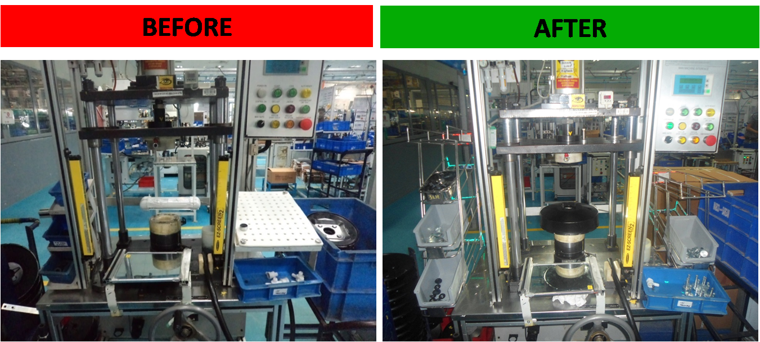

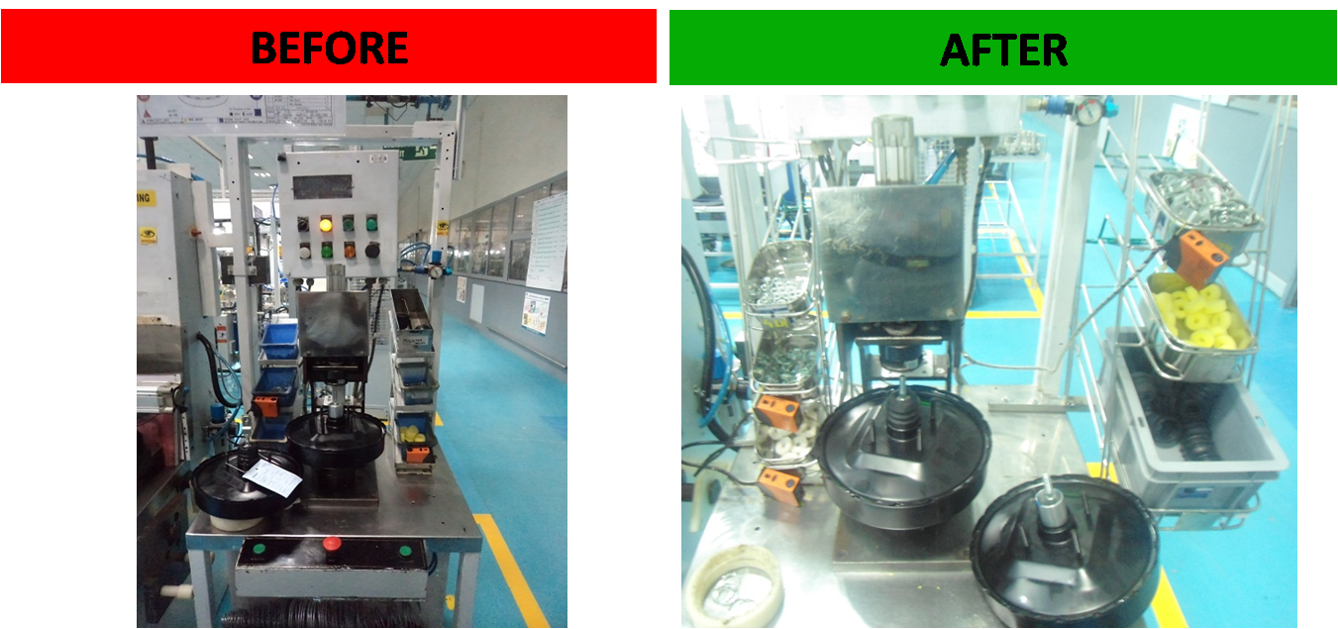

Figure 10: Material Improvements

|  |  |
| --- | --- |
| No standard containers available for the parts.  Parts cannot be fed from the back side. | Ideal size containers in place according to the parts.  Parts can be fed from the gang way |
| Congestion due to the fixed box system where the water spider has to walk in the assembly floor to replenish the material | Congestion is absent due to the bin system |

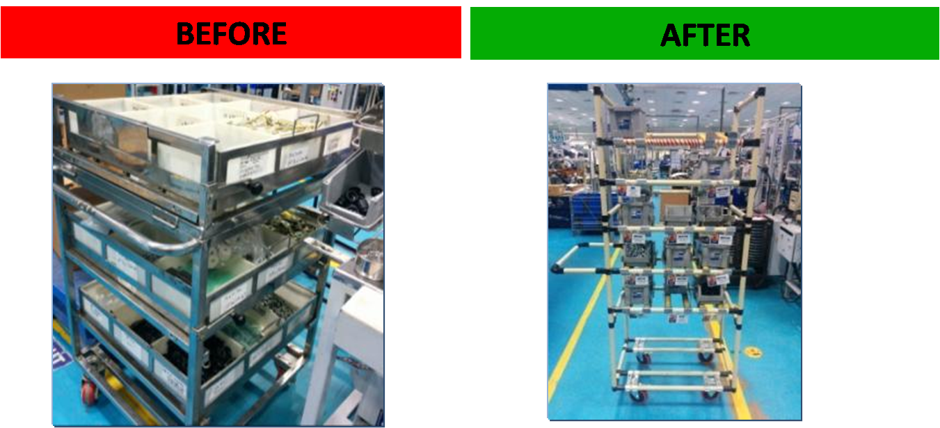

Figure 11: Operating Rod Trolleys

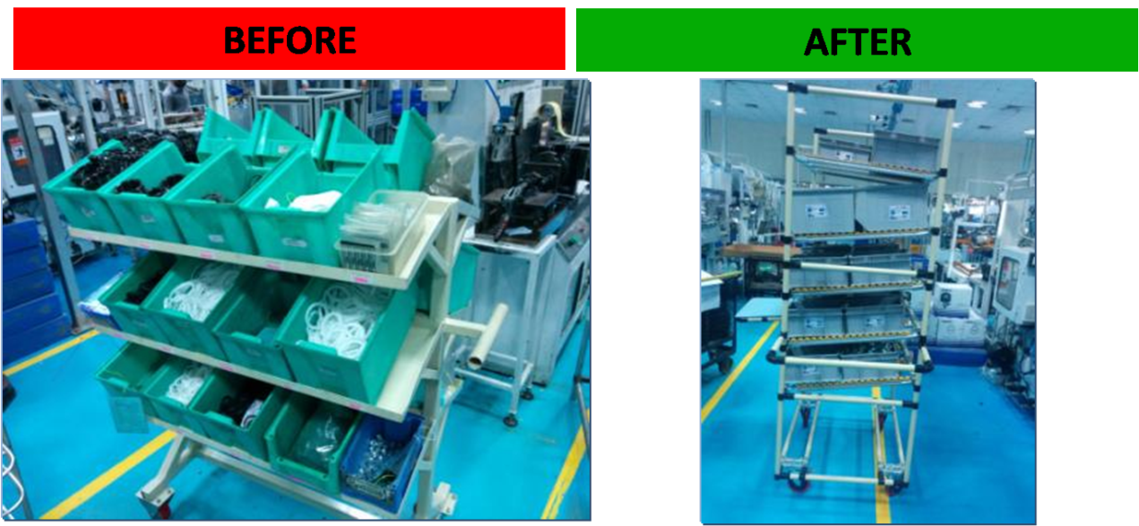 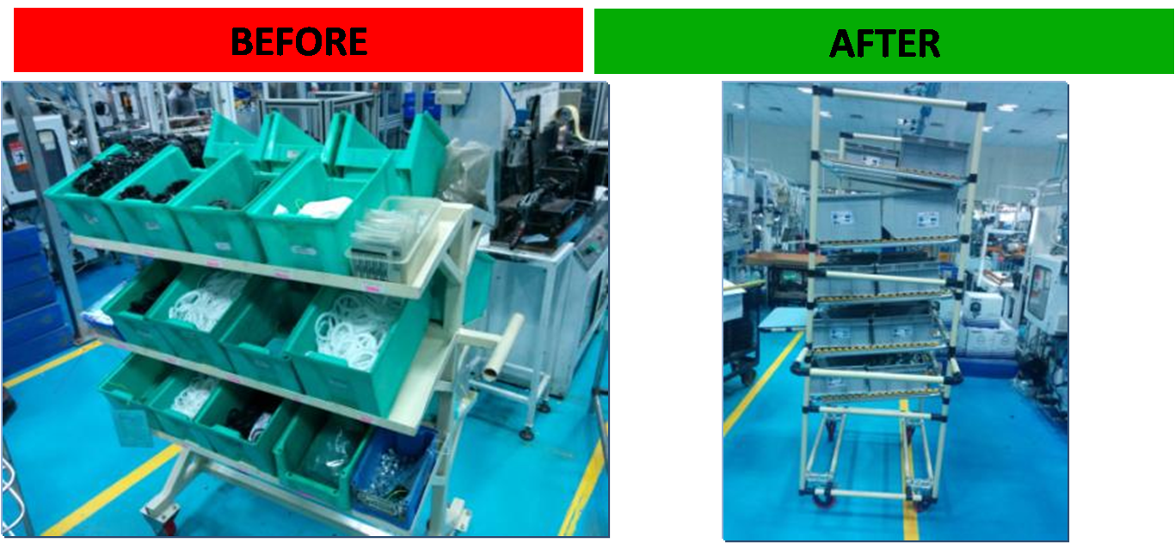

Figure 12: Final Assembly Trolley

|  |  |
| --- | --- |
| No standard containers available for parts Used as a additional storage area with no FIFO & Pull.  Undefined and high inventory in covers | Ideal size containers in place according to the parts.  Parts repacked in stores into the bins and can be fed from backside by the water spider.  FIFO and pull system for specific parts. |

## Line Side Improvements

The following were the improvements made in the line side storage:

* Line side storage was reduced
* Excessive inventory inside the line was eliminated
* Storage of different types of same components in the same trolley exists for the assembly of different variants

## Overall Improvements in Internal Logistics

The following were the improvements obtained in logistic systems:

* Incidental Activities were reduced
* Non-Value Adding Activities were reduced
* NVA activities like counting, writing, waiting and searching has been reduced to zero
* Re-handling and Picking activities were reduced dramatically
* Non-Cyclic activities of the water spider was reduced
* Very less time is spent on searching and waiting
* Standard routes are followed by the water spider
* Line Side storages have been reduced
* The objective of achieving Right Part at Right Time was achieved by using the concepts Of Bin System and Selection of Ideal Containers.
* Built in Quality was achieved by applying the concepts of Signaling Mechanisms (Kanban Bin System), Visual Management along with the concepts of Bin System and Selection Of Ideal Containers.

# Conclusion

Before the implementation of this project it was observed that the current system of logistics was not very efficient .There were a lot of problems due to non-standardized push system that existed in the assembly shop floor. There was excessive inventory, unnecessary space consumption, non-value adding movements of the operators and the water spiders. There was no standard communication that existed between the water spiders and operators so as to convey information on the demand of products.

With the help lean manufacturing and 5S we were able to implement better logistics systems we were able to install a system that followed Right Part at Right Time, Built in Quality, Shorter Lead Time. The objective of getting Right Part at Right Time was achieved by using the concepts of Bin System and Selection of Ideal Containers.

The random movement of Water Spider is standardized by considering the cycle frequency as once in four hours. Built in Quality was achieved by applying the concepts of Signaling Mechanisms (Bin Kanban System), through this concept manual communication is eliminated and now the bay follows pull system. Built in quality was also achieved by the concepts of Visual Management, Bin System and Selection of Ideal Containers.

# Bibliography

•Womack, J. P., Jones, D.T., and Roos, D. (1990). The machine that changed the world: The story of Lean Production. New York: Rawson Associates.

•Fawaz A. Abdulmalek Jayant RajgopalInt, “Analyzing the benefits of lean manufacturing and value stream mapping via simulation: A process sector case study”, J. Production Economics 107, pp. 223–236,2007.

•Lasse saukkorippi (2000), “perspectives on non- valued added activities”, building economics and management, chalmers university of technology, Sweden.

•Rachna Shah Peter T. Ward, “Defining and developing measures of lean production,”Journal of Operations Management 25, pp. 785–805, 2007.

•Matthias Holweg, “The genealogy of lean production”, Journal of Operations Management 25 pp.420–437, 2007.

•www.wikipedia.org

•www.graphicproducts.com